Appendix

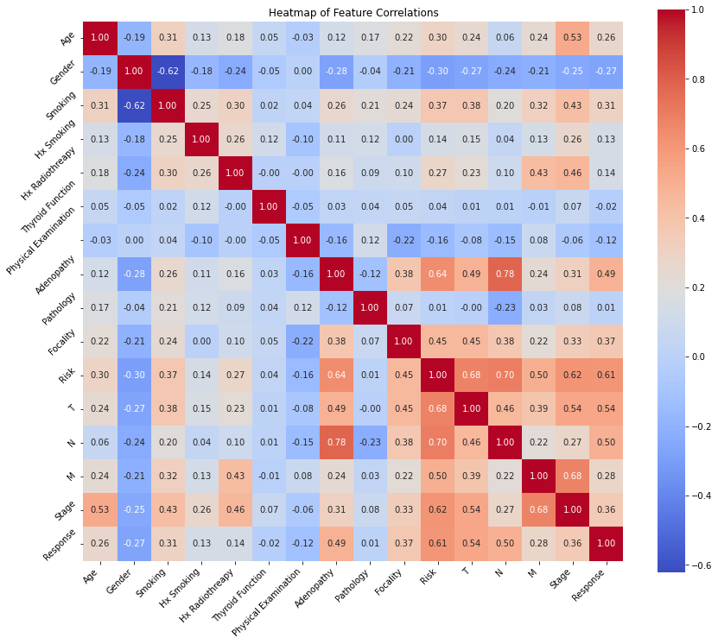

Figure 1. Heatmap of correlations between all features when using multi-class target variable

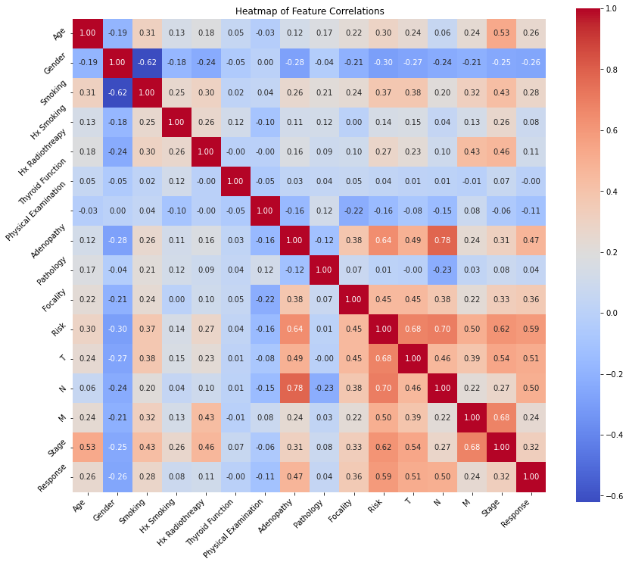

Figure 2. Heatmap of correlations between all features when using binary target variable

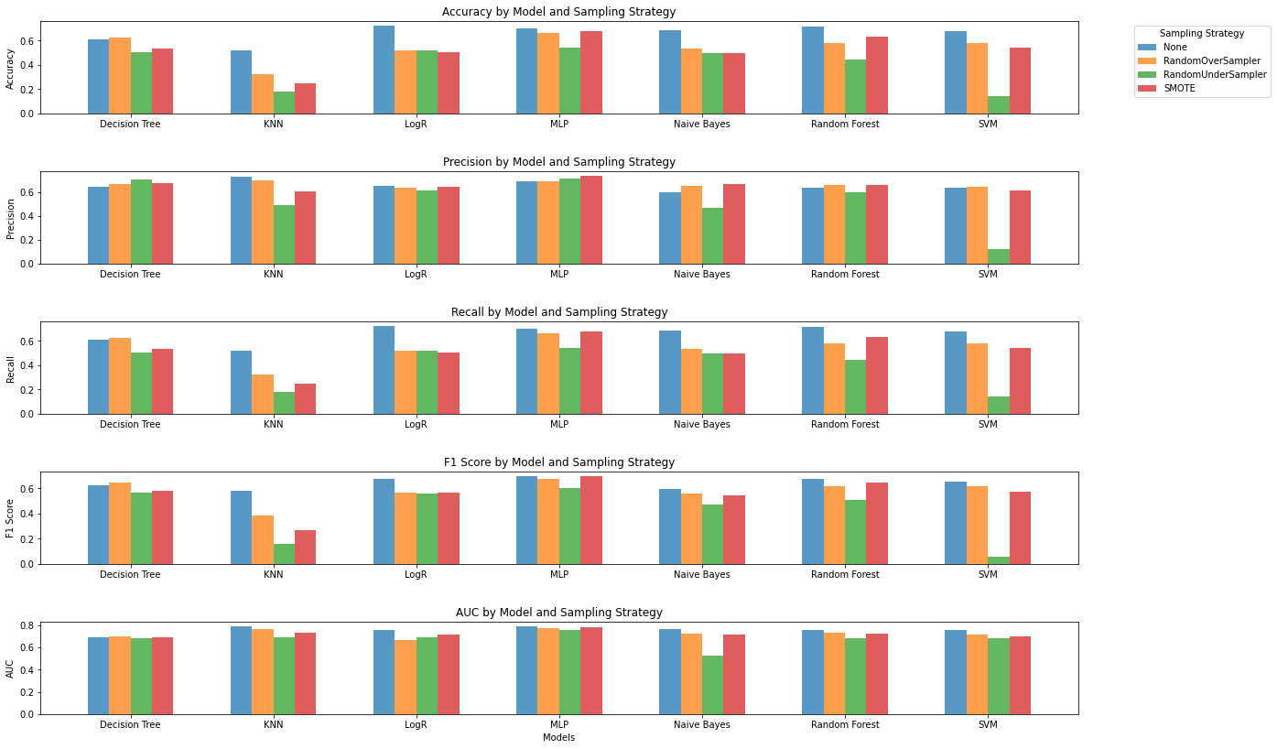

Figure 3. Results of experiment 1 when using different sampling techniques

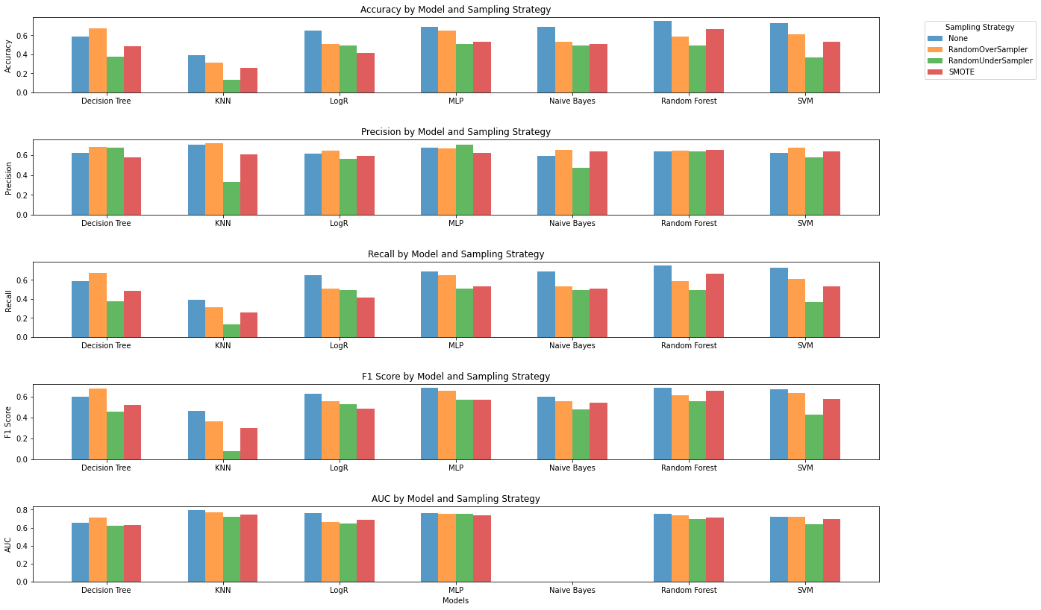

Figure 4. Results of experiment 2 when using different sampling techniques

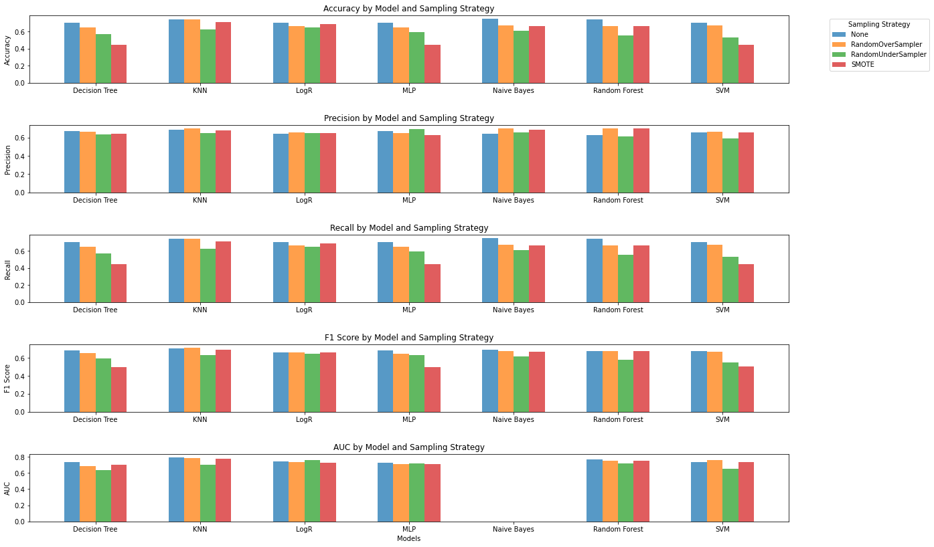

Figure 5. Results of experiment 3 when using different sampling techniques